

**PG&E Electric Distribution**

|  |
| --- |
| ***GIS Web-Viewer Functional Specification*** |

December 15, 2014

Revision History

|  |  |  |  |
| --- | --- | --- | --- |
| **Date** | **Version** | **Description** | **Author(s)** |
| 01/08/15 | V1 | PMO Review | Todd Medrano |
| 1/13/15 | V1.1 | Added WEBR3.101 – 3.111 to the Stored Display segment to support deployment of UFM to Central Valley / Coast | Todd Medrano |
| 2/26/15 | V1.2 | Added existing requirement from SETR3 regarding viewing Primary Meters and Primary Generation | Todd Medrano |

Document Reviewers

|  |  |
| --- | --- |
| **Title** | **Name** |
| PG&E Project Director | Ahmad Ababneh |
| PG&E Project Manager | Nick Moran |
| PG&E Project Director | Rajesh Arora |
| Training & Deployment Manager | Jerry Baughman |
| IT Program Analyst | George Nadar |

The intended audience includes project leads, functional leads, technical leads, functional staff, and technical staff such as programmers / developers from PG&E and ED GIS Asset Management implementation partners.

**Table of Contents**

Table of Contents 3

1 Overview 5

1.1 Application & User Scope 5

1.2 Application Development Lifecycle 6

1.3 IT Methodology & Deliverables 6

2 Underground Facilities Stored Displays & Symbology 8

2.1 Description & Business Requirements: 8

2.2 Use Case: View Underground Facilities 11

3 SAP Work History 12

3.1 Description & Business Requirements: 12

3.2 Use Case: SAP Work History 14

4 Tools & Searching 14

4.1 Description & Business Requirements: 14

4.2 Use Case: Search by Vault Number 15

5 Printing & Templates 16

5.1 Description & Business Requirements: 16

5.2 Use Case: Print Template One to PDF 18

6 Feature Attributes 18

6.1 Description & Business Requirements: 18

6.2 Use Case: Run Trace & Display Equipment Attributes 19

7 Tracing 20

7.1 Description & Business Requirements: 20

7.2 Use Case: Conduit Tracing 20

8 Display Substation Facilities 21

8.1 Description & Business Requirements: 21

8.2 Use Case: Display Substation Normal Open Points 21

9 Crew Location Display 22

9.1 Description & Business Requirements: 22

9.2 Use Case: Support Real Time Crew Location Data Display 22

10 Outage Display 23

10.1 Description & Business Requirements: 23

10.2 Use Case: Outage Data Display 25

11 Job Editor Tool 25

11.1 Description & Business Requirements: 25

11.2 Use Case: Outage Data Display 25

12 Viewing Primary Meters and Generation 25

12.1 Description & Business Requirements: 25

# 

# Overview

## Application & User Scope

PG&E has deployed the GIS Web-Viewer to General Users, Estimators and Engineers. This specification contains the requirements for GIS Web-Viewer Release 4 enhancements to expand business function support for those user groups. The Functional requirements have been grouped into the following 10 functional categories:

* Underground Facilities Display
* SAP Work History
* Tools & Searching
* Printing & Templates
* Feature Attributes
* Tracing
* Crew Location
* Outage Display
* Substation Facilities
* GIS Job Editor Tool

The GIS Business Process Team facilitated multiple requirements workshops with PG&E Stakeholders from Estimating, Mapping and Engineering Business functions from October through December 2014. During those workshops, application demonstrations were conducted with users from Fresno, Stockton, Merced, Cupertino and San Jose.

Requirements from those sessions were collected and presented to business leadership for approval. Multiple review sessions with the AM/GIS Project Leadership were conducted to validate and approve the requirements.

The end-user scope for GIS Web-Viewer Release 4.0 (August 2015) includes:

* **General Audiences:** All Web-Viewer users will have access to enhanced Electric Distribution displays, attributes, loading data, trace, query and print functionality contained within this functional specification.
* **Engineering:** The solution will be enhanced to include enhancements for equipment settings within the context of Primary Meters. The solution will also be enhanced to include display of Fault Duty data. A subset of both of those requirements have been included in this this document to ensure continuity of design. Those requirements are included in Appendix B of the “EDER4 Functional Specification V1.7” and “Transformer Loading Management Functional Specification V1.4” respectively.
* **Estimating:** The Job Editor Tool will be integrated with the GIS Web-Viewer User Interface and deployed in Release 4.0. Some requirements have been included in this document to ensure continuity of design. The detailed requirements are contained in the “Job Editor Tool Release 1 Functional Specification”.

## Application Development Lifecycle

At the time of writing this document, no major releases are planned for Web-Viewer beyond Release 4 in June of 2014. This release is intended to primarily support deployment of Bay Region data and is focused on viewing, querying and printing underground facilities. Release 4 will follow the software process steps outlined below:

1. Requirements Gathering / Functional Specification
2. Solution Blueprint / Detailed Design
3. Software Development
4. Testing Cycles
   * Unit Tests in Development Environment
   * Vendor Package Testing in a Web Test Environment
   * System Testing in QA Environment
   * End-to-End Test Cycle in the Production Environment
5. Documentation
   * Application help files and software documentation will be built and delivered during Vendor Package Testing.
6. Packaging / Distributing / Installation
   * Preliminary release packages and installers will be delivered for Vendor Package Testing.
   * Final packaging and installers will be released after End-to-End testing has been completed.
7. End-User Training
8. End-User Support

## IT Methodology & Deliverables

The IT Methodology consisting of 16 key deliverables as well as control and compliance inputs into PPMc. It is mapped for both application and infrastructure projects to use and aligns with an organizational model where delivery resources are managed under one roof as opposed to functionally-organized resources.

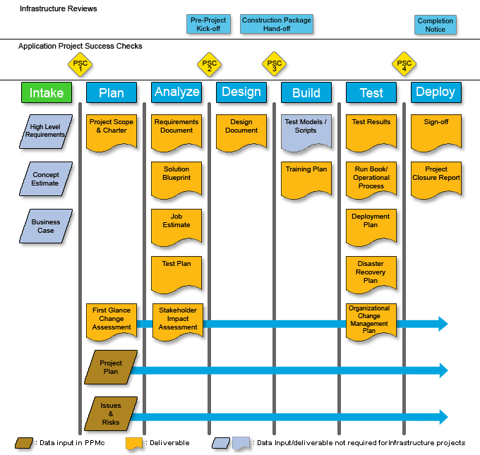

In the technical area, the IT Methodology leverages more integrated planning and execution from the various business and technical experts, rather than relying on documents to be “tossed over the fence” when completed. The methodology documents will support closer collaboration of business experts, subject matter experts, and IT resources.

The accountability for completion of the required deliverables still lies with the project manager.

The PM will continue to work with all relevant project team members and functional and technical teams to plan and execute the project. As part of the new process, projects will continue to participate in IT Governance reviews to ensure compliance with the new methodology.

**Documentation Definitions:**

Project Deliverable: A required document to support the project management methodology. All IT projects, application and infrastructure, are to complete the deliverables. A project deliverable must be approved by key stakeholders and stored for audit purposes.

Project Artifact: A supporting document which is created during the project which facilitates communication, design, build, or implementation. A project artifact does not need to be approved and stored for audit purposes.

**Technical Standards and Best Practices:**

The IT Methodology is not meant to replace current technical, security, development or accounting standards and best practices. These standards and best practices should still be followed and enforced. Examples include database and field naming conventions, coding standards, vendor standards (e.g. SAP), accounting department standard practice, etc.

**Documentation Retention Requirements:**

Project documentation for application projects should be kept for a period of no less than seven (7) years from the completion of the project, but could be longer depending upon specific CPUC, regulatory, or legal requirements. The project manager should consult the applicable business leads for these requirements. All documentation is routed for approval in EDRS and final, completed, and signed documentation is stored in EDMS.

Project documentation for infrastructure projects should be kept for a period of no less than seven (7) years from the completion of the project, but could be longer depending upon specific CPUC, regulatory, or legal requirements. The project manager should consult the applicable business leads for these requirements. All infrastructure documentation is routed for approval and stored in PPMc.

# Underground Facilities Stored Displays & Symbology

## Description & Business Requirements:

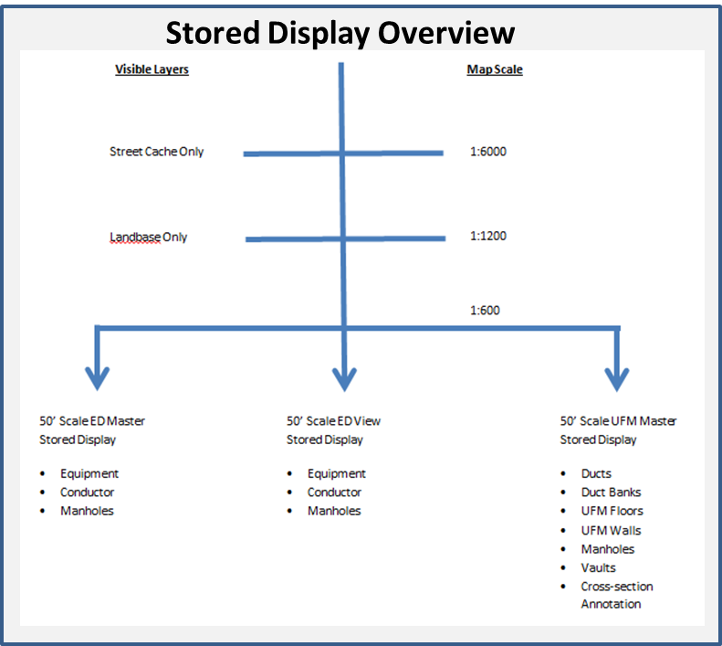

Due to the complexity of underground facilities data, Web-Viewer Users require specialized stored displays to support disparate business functions.

Users also require functionality to support searching for underground facilities and determining feature relationships using query filters.

Essential to data viewing and map reproduction are scale based rendering of feature annotation and labeling.

The following requirements outline the ED Master, ED Display, UFM Duct View, Circuit and Schematic Stored Displays for underground facilities at 1”-250’, 1”-100” and 1”-50”.

**Business Requirements:**

| **Number** | **TFS ID** | **Requirement Statement** |
| --- | --- | --- |
| WEBR4005 | 18427 | The solution will support the display of multi-polygonal vault features. |
| WEBR4006 | 18428 | The solution will end ducts at the vault wall. |
| WEBR4007 | 18429 | The solution will continue circuit through the vault wall. |
| WEBR4008 | 18430 | The solution will display ducts and vaults as their actual shapes with cross-section annotation (No conductor) below or at 1”-20’. |
| WEBR4009 | 18431 | The solution will display labeled conductor (No ducts), below or at 1”-20’. |
| WEBR4010 | 18432 | The solution will display only landbase above 1”-100’. |
| WEBR4011 | 18433 | The solution will display ducts and vaults as nodes with vault ID’s below or at 1”-100’, but above 1”=90’. |
| WEBR4012 | 18434 | The solution will display ducts and vaults as polygons with vault ID’s below or at 1”-90’, but above 1”=45’. |
| WEBR4013 | 18435 | The solution will display ducts and vaults as their actual shapes with vault ID’s below or at 1”-45’, but above 1”=20’. |
| WEBR4014 | 18436 | The solution will display ducts and vaults as their actual shapes with cross-section annotation below or at 1”-20’. |
| WEBR4015 | 18437 | The solution will support right click display of Butterfly Diagrams when a vault polygon is selected. |
| WEBR4016 | 18438 | The solution will have a “hover-functionality” such that when a duct is hovered over, it would display the duct cross-section. |
| WEBR4017 | 18439 | The solution will support display of Protective Device Fault Duty and CYME Loading Values. |
| WEBR4018 | 18440 | The solution will support manual entry of an exact scale to support viewing of data sets. |
| WEBR4019 | 18441 | The solution will default "Hover Over" to "ON" and delay display to prevent interference with viewing data. |
| WEBR4021 | 18444 | The solution will provide three stored displays types with symbols and annotation drawn at a 1’:50” and 1”:100’ scale. |
| WEBR4022 | 18445 | The solution will provide a 50’ Scale ED Master Stored Display that will include equipment, conductor and manholes at a 1”:50’ and 1’:100” scale. |
| WEBR4023 | 18446 | The solution will provide a 50’ Scale UFM Master that will include ducts, duct banks, UFM floors, UFM Walls, Manhole/Vaults and cross section annotation at a 1”:50’ and 1”:100’ scale. |
| WEBR4024 | 18448 | The solution will provide a 50’ and 100’ Scale ED Views that is a simplified version of the 50’ and 100’ Scale UFM Master stored displays that includes only the feature classes required for printing and general viewing. |
| WEBR4025 | 18449 | The solution will provide a 1”:50’ Circuit Map stored display. |
| WEBR4026 | 18450 | The solution will provide a 1”:250’ Schematics stored display. |
| WEBR4027 | 18451 | The solution will symbolize available, filled and abandoned conduit. |
| WEBR4028 | 18452 | The solution will display only landbase at 1”=100’ |
| WEBR4029 | 18453 | The solution will display ducts and vaults as nodes with vault ID’s below or at 1”=100’, but above 1”=90’. |
| WEBR4030 | 18454 | The solution will display ducts and vaults as polygons with vault ID’s below or at 1”=90’, but above 1”=45’. |
| WEBR4031 | 18455 | The solution will display ducts and vaults as their actual shapes with vault ID’s below or at 1”=45’, but above 1”=20’. |
| WEBR4032 | 18456 | The solution will display ducts and vaults as their actual shape with cross-section annotation below or at 1”=20’. |
| WEBR4033 | 18457 | Display order of UFM data display will be Conductor first, Vault Polygon second and Conduit last. |
| WEBR4034 | 18458 | The solution will symbolize conduit that by-pass a vault. |
| WEBR4035 | 18460 | The solution will draw all symbols and annotation at a 1’:50” reference scale. |
| WEBR4037 | 18461 | The solution will ensure that duct banks are mirrored between underground structures. |
| WEBR4038 | 18462 | The Cross Section Annotation for conductor will include; Feeder / Conductor Number / Size / Material / Simplex or Duplex. |
| WEBR4039 | 18463 | Annotation will be shown on the duct bank showing the direction that the duct is facing or the vault destination. |
| WEBR4040 | 18464 | The solution will have the ability to display duct cross-section and its associated annotation. |
| WEBR4041 | 18465 | The solution will have the ability to display duct size. |
| WEBR4042 | 18466 | The solution will have the ability to display duct material. |
| WEBR4043 | 18467 | The solution will have the ability to display vault type. |
| WEBR4050.1 | 18468 | The solution will individually symbolize Patrol (Preventative Inspection), Inspection (Preventative Inspection), DET (Preventative Inspection), Pole Test and Treat (Preventative Inspection), EC tags (Corrective Work), and Planned/PM work (Corrective Work). |
| WEBR4071 | 18427 | The solution will ensure that arrows indicate the direction that a cross section is facing. |
| WEBR4072 | 18428 | The solution will support symbolization of conduit that passes by a vault. |
| WEBR4073 | 18429 | The solution will symbolize available, filled and abandoned conduit. |
| WEBR4074 | 18430 | The solution will support display of the Anchor Guy Feature and attributes. |
| WEBR3.101 | 18845 | The solution will provide 1:100 ED Master Stored Display that includes the UFM Data Set. |
| WEBR3.102 | 18846 | The solution will default the UFM Data Set to “Off” in the ED Master Stored Display. |
| WEBR3.103 | 18847 | The solution will support turning the Primary Network to “Off” suppressing the display of the entire data set in the Electric Distribution Stored Display. |
| WEBR3.104 | 18848 | The solution will support turning the Secondary Network (Including Direct Current & Streetlights) to “Off” suppressing the display of the entire data set in the ED Master Stored Display. |
| WEBR3.105 | 18851 | The solution will display Conduit, Cross Section Anno, Floor and Duct Bank when the UFM Data Set is selected in the 1:100 ED Master Stored Display. |
| WEBR3.106 | 18856 | The solution will display Floor, Vault, Enclosures, Subsurface Structure, Conduit, De-Activated Conduit and Cross Section Anno, layers when the UFM Data Set is selected in the 1:100 ED Master Stored Display. |
| WEBR3.107 | 18857 | The solution will provide 1:100 Electric Distribution Stored Display that includes the UFM Data Set. |
| WEBR3.108 | 18858 | The solution will default the UFM Data Set to “Off” in the ED Electric Distribution Stored Display. |
| WEBR3.109 | 18859 | The solution will support turning the Primary Network to “Off” suppressing the display of the entire data set in the ED Master Stored Display. |
| WEBR3.110 | 18860 | The solution will support turning the Secondary Network (Including Direct Current & Streetlights) to “Off” suppressing the display of the entire data set in the Electric Distribution Stored Display. |
| WEBR3.111 | 18861 | The solution will display Floor, Vault, Enclosures, Subsurface Structure, Conduit, De-Activated Conduit and Cross Section Anno, layers when the UFM Data Set is selected in the 1:100 Electric Distribution Stored Display. |

## Use Case: View Underground Facilities

***Main Flow:***

1. User selects 50’ Scale ED Master from the Stored Display dropdown list
2. The system toggles all other data sets to non-visible
3. The system toggles all layers specified in the selected stored view configuration to visible.
4. User enters 1”-100’ scale and observes landbase and vaults as nodes with Vault ID’s
5. User enters 1”-45’ scale and observes ducts and vaults as their actual shapes
6. User enters 1”-20’ scale
7. User observes available, filled and abandoned conduit within the map extent
8. User observes symbolized conduit that by-pass vaults within the extent of the map
9. User observes duct banks are mirrored between vaults and the direction that the duct
10. User observes duct size, material and type annotation
11. User selects a vault and right clicks to display the Butterfly Diagram
12. User observes vault the outline of the vault floor, walls, and connectivity of facilities

**Alternate Flow 1: View EC Tag Symbology**

1. Select Search Toolbar, select Switch, enter Operating Number, system returns search
2. User observes EC Tag Symbol on the switch
3. User selects switch in the Attribute Viewer

# SAP Work History

## Description & Business Requirements:

The SAP ID is used by Mapping and other business functions to look up equipment in GIS in SAP. This cross reference capability will also be used to support Quality Assurance activities. GIS Web-Viewer will have an interface with SAP Work and Device History that will allow users to have the ability to access facility history to support researching work history and activities around device failure, inspection, maintenance and replacement.

**Business Requirements:**

|  |  |  |
| --- | --- | --- |
| **Number** | **TFS ID** | **Requirement Statement** |
| WEBR4048 | 1683 | The solution will support linking the SAP Work / Equipment History for all Electric Distribution Facilities. |
| WEBR4048.1 | 18540 | The solution will support right click display of SAP / Equipment History. |
| WEBR4048.2 | 18541 | The solution will support cut and paste work order history. |
| WEBR4050.1 | 1683 | The solution will provide the ability to view the following types of SAP Work and Device history/planned work: Patrol (Preventative Inspection), Inspection (Preventative Inspection), DET (Preventative Inspection), Pole Test and Treat (Preventative Inspection), EC tags (Corrective Work), and Planned/PM work (Corrective Work). |
| WEBR4050.2 | 18475 | The solution will provide an option to view the SAP Work and Device history/planned work for a device via a rollover and right click option in the map window. |
| WEBR4050.3 | 18477 | The solution will provide the ability to view the following information for the SAP Work and Device history/planned work for a given device: Type of work, Type of notification, ‘FID’ (Facility, Inspection/Problem, Do/Action), Date of work (creation date if open, closed date if closed), Due Date, Priority and PM Order # (if applicable – relate to also get the MAT, Work Type Code, Major Work Categories, Hours) |
| WEBR4050.4 | 18478 | The solution will display SAP Work and Device history/planned work for a given device in the following order: Preventative Inspection (Open), Corrective Work (Open), Preventative Inspection (Closed) and Corrective Work (Closed). |
| WEBR4050.5 | 18479 | The solution will allow SAP Work and Device history/planned work to be exported to Microsoft Excel for all devices: In a user drawn area and In a trace result |
| WEBR4050.6 | 18480 | The solution will export SAP Work and Device history/planned work for a set of devices in the following order: Preventative Inspection (Open), Corrective Work (Open), Preventative Inspection (Closed) and Corrective Work (Closed) |
| WEBR4050.7 | 18481 | The solution will provide the ability to export the following information for the SAP Work and Device history/planned work for a set of devices: Type of work, Type of notification, ‘FID’ (Facility, Inspection/Problem, Do/Action), Date of work (creation date if open, closed date if closed), Due Date, Priority, Location values – addresses, source side device, lat/long and PM Order # (if applicable – relate to also get the MAT, Work Type Code, Major Work Categories, Hours) |
| WEBR4050.8 | 18482 | The solution will have the ability to view or export SAP Work and Device history/planned work where the information is related to a map/maintenance plat (Patrols and Inspections) and not directly to the device/structure. |
| WEBR4050.9 | 18483 | The solution will display SAP Work and Device history/planned work for a limited historical period based on the Inspection or Work cycle period. |
| WEBR4050.10 | 18484 | The solution will have the ability to visualize, for a specific type of work or inspection, on the Web Viewer map window SAP Device planned work against the related devices/structures. |
| WEBR4050.11 | 18485 | The solution will allow SAP Work and Device history/planned work to be visualized on the Web Viewer map window for all devices: In a user drawn area and In a Trace Result. |
| WEBR4050.12 | 18486 | The solution will visualize SAP Device planned work on the Web Viewer map according to the work due date as follows: Due Date within the next 6 months, Due Date 6-12 months, and Due Date > 12 months. |
| WEBR4050.13 | 18492 | The solution will visualize SAP Device planned work on the Web Viewer map according to the work Priority. |
| WEBR4050.14 | 18495 | The solution will support printing of the planned work in the Web Viewer Silverlight printing functionality only. |

## Use Case: SAP Work History

***Main Flow:***

1. User executes trace, identify or search operation
2. The system executes user submitted operation
3. The system returns analysis results to the attribute viewer and map display
4. User selects the equipment from the attribute viewer, right clicks to call up the PM Order History
5. The system opens hyperlink in new tab in browser

# Tools & Searching

## Description & Business Requirements:

The GIS Web-Viewer is deployed across business functions at PG&E. Users require tools to search for the specific features and filter out data that is not needed to perform their job functions. The tool requirements contained in this section focus on allowing end-users to save customized views and bookmarking datasets as default views. The searching requirements focus on enabling querying underground facilities and determining the relationships between features.

**Business Requirements:**

|  |  |  |
| --- | --- | --- |
| **Number** | **TFS ID** | **Requirement Statement** |
| WEBR4076 |  | The solution will have the ability to search by vault number. |
| WEBR4077 |  | The solution will have the ability to search by manhole number. |
| WEBR4078 |  | The solution will have the ability to save GIS layers as favorites. |
| WEBR4081 |  | The solution will have the ability to highlight one or more circuits. |
| WEBR4082 |  | The solution will have the ability to display a list of customers associated with a particular duct / duct bank. |
| WEBR4083 |  | The solution will have the ability to display a list of customers associated with a particular vault. |
| WEBR4084 |  | The solution will have the ability to filter by tie-cables / network cables. |
| WEBR4085 |  | The solution will provide a report on manholes by circuit. |
| WEBR4086 |  | The solution will support automated clearing of the Silverlight cache without deleting saved user preferences. |
| WEBR4087 |  | The solution will support selection and de-selection of layers by clicking on the first term in the layer hierarchy. |
| WEBR4088 |  | The solution will support "Bookmarking" GIS data sets and layers to be displayed each time on start-up. |
| WEBR4088.1 | 18618 | The solution will support filtering by conductor type. |

## Use Case: Search by Vault Number

***Main Flow:***

1. User selects “Vault” Search Toolbar
2. User selects “=” equal filter
3. User enters the Vault Number
4. The system executes the search
5. Search results are returned
6. User selects the vault by clicking on the feature row within the attribute viewer
7. The system highlights the selected row
8. The vault is flagged with a visual indicator and the attributes are displayed in the Attribute Viewer

# Printing & Templates

## Description & Business Requirements:

Map templates may contain base map layers or be a variety of commonly used page layouts. Map templates make it easy to reuse or standardize a layout on a series of maps. Using a template can save time, since the user doesn't have to manually reproduce the common parts of the maps. Like maps and layers, templates can be shared within an organization to increase productivity and standardize the maps that the organization produces.

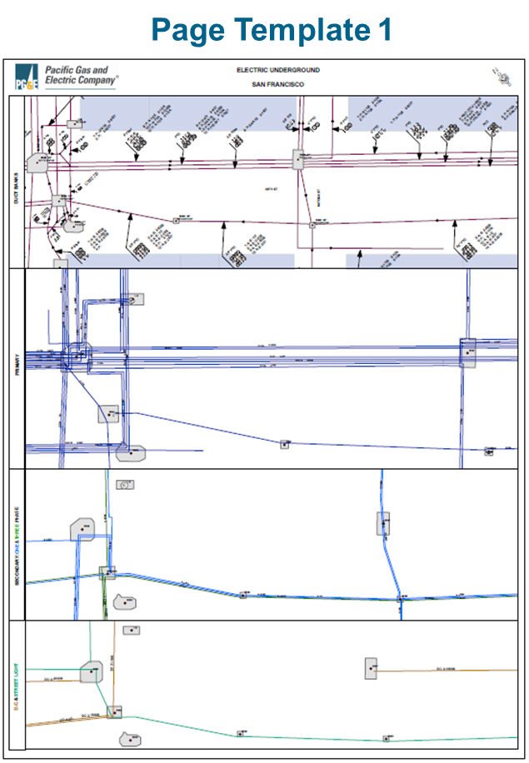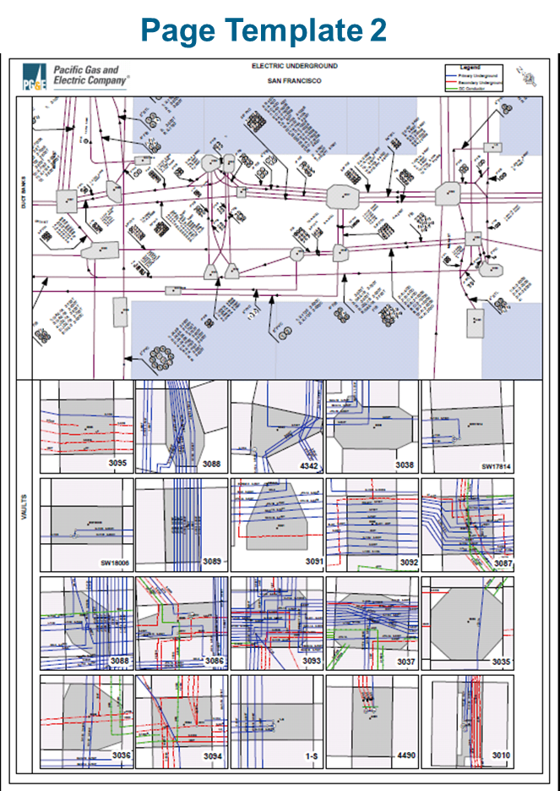

Standardized page templates can be used throughout the organization to print map products. Using standard page templates increases the productivity of the map production process. Page Template #1 will provide a consolidated map product that provides information about the manholes, DC conductors, secondary conductors and primary conductors for each block in San Francisco.

Page Template #2 will provide a consolidated map product that provides detailed information for selected manholes. This template will provide an overview of the block with the vault polygons, cross section annotations, and conduit system lines in the top section. The bottom section will contain detailed inset maps of each vault that includes the butterfly diagram, conductors, and conduit system.

**Business Requirements:**

|  |  |  |
| --- | --- | --- |
| **Number** | **TFS ID** | **Requirement Statement** |
| WEBR4051 | 18497 | The solution will support splitting the extent of a plotting template and output two 11X17 pieces of paper. |
| WEBR4052 | 18498 | The solution will ensure that page templates show vents that connect vaults. |
| WEBR4053 | 18499 | The solution will have the ability to print plotter size print outs. |
| WEBR4054 | 18500 | The solution will have the ability to print 11x17 size maps |
| WEBR4055 | 18501 | The solution will support printing all of the data contained in the Detailed Attribute View Window. |
| WEBR4057 | 18503 | The solution will have the ability to output Page Template 1 by highlighting a set of vaults. |
| WEBR4058 | 18504 | The solution will contain Page Template 1 which will show vaults and duct banks in the top section. |
| WEBR4059 | 18505 | The solution will contain Page Template 1 that shows primary conductor in the upper middle section. |
| WEBR4060 | 18507 | The solution will contain Page Template 1 that shows secondary conductor in the middle section. |
| WEBR4061 | 18508 | The solution will contain Page Template 1 that shows DC and street light conductor in the lower section. |
| WEBR4062 | 18509 | The solution will have the ability to output Page Template 2 by highlighting a set of vaults. |
| WEBR4063 | 18510 | The solution will contain Page Template 2 that will include a legend. |
| WEBR4064 | 18511 | The solution will contain Page Template 2 that will show vaults polygons, cross section annotation, and conduit lines in the top section. |
| WEBR4065 | 18512 | The solution will contain a Page Template 2 that will show butterfly diagrams in the bottom section as inset maps. There should be one inset per vault. The inset maps will contain conductor lines and butterfly diagrams. |
| WEBR4066 | 18513 | The solution will contain a Page Template 2 that will have the ability to show 20 butterfly diagrams simultaneously. |
| WEBR4067 | 18514 | The solution will contain a Page Template 2 that will use the client-designated line style. (Shown a Page Template 2 Legend) |
| WEBR4068 | 18515 | The solution will contain a Page Template 2 that will show the vault number in each butterfly diagram inset. |
| WEBR4069 | 18516 | The solution will produce 1”:50’ .tiff and PDF maps products for the datasets listed below in the Bay Area Region; Landbase, Electric Distribution, Substation, Schematics, Circuit Map, and Underground Facilities. |
| WEBR4070 | 18517 | The solution will produce 1”:50’ PDF and Tiff schematic map products for the Bay Area Region. |

## Use Case: Print Template One to PDF

***Main Flow:***

1. User positions the map on desired area
2. User selects “Templates” from the tool bar
3. System displays the Template Printing Dialog
4. User selects the Template, Grid type and Grid Number they desire
5. System displays the users selected template
6. System changes the scale to the preset scale defined by the Grid Layer/Grid Number’s set scale
7. User selects the print button
8. System presents the page template viewer
9. User selects the desired paper size and orientation
10. User selects the “Print to PDF” button
11. System produces a PDF using requested Template, Grid Layer/Grid Number, Scale and Paper size values
12. System returns the PDF to the user
13. System requests where to save the PDF
14. User Saves the PDF map to the local drive

# Feature Attributes

## Description & Business Requirements:

The following enhancements to feature attributes were identified by users to support productivity by reducing the amount of time required to further research device details. One example of this is protective devices displayed under the feature class title of “Dynamic Protective Device”. Future requirements now dictate “Recloser” (Sub-Type Name) be listed instead of “Dynamic Protective device. In addition, Engineers have requested that loading data be displayed as attributes pulled directly from the Transformer Loading Application.

**Business Requirements:**

| **Number** | **TFS ID** | **Requirement Statement** |
| --- | --- | --- |
| WEBR4044 | 18469 | The solution will identify the specific type of dynamic protective device in trace results. |
| WEBR4045 | 18470 | The solution will display subtype as opposed to Open Points in trace results. |
| WEBR4046 | 18471 | The solution will indicate what devices are SCADA in trace results. |
| WEBR4047 | 18472 | The solution will display Substation Field Properties and UFM Feature Classes in accordance with the "GIS Substation Field Properties Workbook". |
| WEBR4093 | 18539 | The solution will display the following on Special Loads:   * Description * Summer KW / Summer KVAR * Winter KW / Winter KVAR * Date Created * Last Modified |
| WEBR4092 | 18146 | The solution will support hover over display of Source Side Device / Protective Device / Auto Protective. |

## Use Case: Run Trace & Display Equipment Attributes

***Main Flow:***

1. Select the Upstream Tool from the Tracing Tab
2. Place the trace starting point on the circuit
3. System performs the upstream trace operation and returns results in order of electrical connectivity
4. Geographic extent of the trace is re-drawn to include tracing results
5. User selects the Recloser Tab and highlights the specific device to view attributes

# Tracing

## Description & Business Requirements:

Due to the complexity of underground facilities data, Web-Viewer Users require the ability to run traces that return electrical connectivity within the context of underground structures. There are two scenarios that involve the following requirements. In the first, users are required to trace a circuit and determine access points to electric distribution equipment. In the second, users are required to determine the relationships of vaults and conduit.

**Business Requirements:**

|  |  |  |
| --- | --- | --- |
| **Number** | **TFS ID** | **Requirement Statement** |
| WEBR4079 |  | The solution will support traverse geo-network tracing, tracing by adjacent vault, tracing from one vault to another based on filter selection. |
| WEBR4080 |  | The solution will display conduit trace results in the order of connectivity. |
| WEBR4090 |  | The solution will support selection of conductor and the display of the vaults that the conductor passes through. |
| WEBR4091 |  | The solution will have the ability for a user to select a conductor and identify all the vaults that the selected conductor runs through. |

## Use Case: Conduit Tracing

***Main Flow: Electrical Trace with Vault Display***

1. Select the Upstream Tool from the Tracing Tab
2. Place the trace starting point on the circuit
3. System performs the upstream trace operation and returns results in order of electrical connectivity
4. Geographic extent of the trace is re-drawn to include tracing results
5. User observes Vaults that the circuit passes through in the Attribute Viewer

***Alternate Flow: Trace Conduit***

1. Select the Conduit Tracing Tool from the Tracing Tab
2. Place the trace start and end points on the conduit
3. System performs the trace operation and returns results in order of connectivity
4. Geographic extent of the trace is re-drawn to include trace results
5. User observes the conduit path through the underground facilities

# Display Substation Facilities

## Description & Business Requirements:

It is required that users have the ability to view the open points are to plan, sectionalize, and determine power flow within a substation. Web-Viewer will support the display of substation normal open points and operating positions. Display of this data will support analysis of bank and circuit loading and outage analysis within substations.

**Business Requirements:**

|  |  |  |
| --- | --- | --- |
| **Number** | **TFS ID** | **Requirement Statement** |
| WEB0082 | 10915 | The solution shall display Substation Normal Open Points. |
| WEBR4075 | 18522 | The solution will display of all substation open devices in the color Green. |
| WEB0082.1 | 18442 | The solution will display Substation devices with a Normal Position (A, B, or C) value = Open with a different symbol to devices where all Normal Position (A, B, and C) values = Closed. |
| WEB0082.2 | 18443 | The following Substation devices will display different symbology for switchable status: Sub Fuse, Sub Generator, Sub Interrupting Device, Sub Link and Sub Switch. |

## Use Case: Display Substation Normal Open Points

***Main Flow:***

1. User selects Substation View from the Stored Views dropdown list.
2. The system toggles all service layers to Non-Visible.
3. The system toggles all layers specified in the selected stored view configuration to Visible.
4. The system displays the selected stored view layers in the map display.

# Crew Location Display

## Description & Business Requirements:

In emergency situations, Web-Viewer Users must be able to determine where crews are located in order to respond to emergency events in a timely fashion. Web-Viewer will support the display of real time crew location data so that a user can quickly determine where crews are working on the electric distribution system.

**Business Requirements:**

| **Number** | **TFS ID** | **Requirement Statement** |
| --- | --- | --- |
| WEB0079 | 10919 | The solution shall support real time crew location data display. |
| WEBR4002.1 | 18395 | The solution will display crew location data as an additional Stored Display in Web Viewer. |
| WEBR4002.2 | 18396 | The symbol for a crew location will be a blue truck. |
| WEBR4002.3 | 18397 | The solution will support a static display of crew locations that is updated on map refresh, pan, or zoom based on the last time the data was received from the Ventyx system. |
| WEBR4002.4 | 18398 | The solution will support printing of the crew locations in the Web Viewer Silverlight printing functionality only. No printing will be available from desktop or Map Production functionality. |
| WEBR4002.5 | 18399 | The following attribute information will be available from the crew locations: Tech ID, Timestamp (last time reported in), Lat/Long and Skillset. |
| WEBR4002.6 | 18488 | The solution will support searching for Mobile Crew Identifier. |

## Use Case: Support Real Time Crew Location Data Display

***Main Flow:***

1. User selects the Layers button.
2. The system displays a tree view list of service layers, sub-groups and feature layers.
3. User toggles a top level Layer group from Non-Visible to Visible.
4. The system sets all groups and sub-layers to Non-Visible.
5. The map reflects layer toggling applied in the layer control displaying real time crew location data.

# Outage Display

## Description & Business Requirements:

Users are required to quickly determine where active outages are and be able to prioritize outages and routing crews, as well as, other resources identified for outage management. Web-Viewer will support real time outage and attribute display.

**Business Requirements:**

| **Requirement** | **ID** | **Requirement Statement** |
| --- | --- | --- |
| WEBR4003 . | 10920 | The solution will support near real time outage data display. |
| WEBR4003.1 | 18400 | The solution will display outage location data as an additional Stored Display in Web Viewer. |
| WEBR4003.2 | 18401 | The symbol for an outage notification will be a buffer of around the Primary Conductor based on the following counts of customers out: 1-49 : Green / 50-499 : Light Orange / 500-4999 : Dark Orange and 5000+ : Red |
| WEBR4003.3 | 18402 | The solution will support a static display of outage notifications that is updated on map refresh, pan, or zoom based on the last time the data was received from the OMS/DMS system. |
| WEBR4003.4 | 18403 | The solution will support printing of the outage notifications in the Web Viewer Silverlight printing functionality only. No printing will be available from desktop or Map Production functionality. |
| WEBR4003.5 | 18404 | The following attribute information will be available from the outage notifications: Outage ID, District Number, Feeder Name, Transformer ID, Estimated Repair Time, Outage Start Time, Cause, and Number of Customers Out. |
| WEBR4003.6 | 18494 | The solution will support searching for OIS Number. |
| WEBR4004 | 18406 | The solution will display transformer outage history (Focal Point). |
| WEBR4004.1 | 10920 | The solution will provide the ability to display an outage history report for a transformer. |
| WEBR4004.2 | 18400 | The solution will provide the ability to print an outage history report for a transformer. |
| WEBR4004.3 | 18401 | The transformer outage history report will display header information including the following: The date on which the report was run, The transformer ID number (CGC #12), The district that the transformer is in, The next source side device upstream from the transformer, The from-date and the to-date that the report covers, and The report title, that is, Transformer Outage History Report. |
| WEBR4004.4 | 18410 | The transformer outage history report will display sustained interruptions and a record of momentary interruptions in separate sections with sustained interruptions shown first and momentary interruptions second. |
| WEBR4004.5 | 18411 | For sustained interruptions the transformer outage history report will display one row per interruption. |
| WEBR4004.6 | 18413 | For sustained interruptions the transformer outage history report will display the following data: Date and Time of the outage, Report Number, Outage Type, Basic Cause, Minutes Out of Service, Open Point Type, Open Point Operating Number and Circuit Number. |
| WEBR4004.7 | 18415 | The transformer outage history report will define any outage with duration of greater than 5 minutes as a sustained outage. |
| WEBR4004.8 | 18416 | For momentary interruptions the transformer outage history report will display the following data: Date and Time of the outage, Report Number, Outage Type, Basic Cause, Customers affected, Open Point Type, Open Point Operating Number, Open Point Operating Number, and Circuit Number. |
| WEBR4004.9 | 18417 | The transformer outage history report will define an outage with duration of 5 minutes or less as a momentary outage. |
| WEBR4004.10 | 18418 | The solution will make the transformer outage history report available based on selecting a service transformer. |
| WEBR4004.11 | 18419 | The solution will provide a dialog for the user to enter the following report parameters: Transformer ID (CGC#12 or Tnum) or Service Point ID, Start Date, and Stop Date. |
| WEBR4004.12 | 18420 | For momentary interruptions the transformer outage history report will display one row per interruption. |
| WEBR4004.13 | 18421 | The transformer outage history report will be accessible to users through selection of a customer    from a list. |
| WEBR4004.14 | 18422 | The transformer outage history solution will use all the outage history data available from the legacy CEDSA database. |
| WEBR4004.15 | 18423 | The Outage Reporting and Analysis System Replacement project will convert at least seven years of CEDSA outage history into a data warehouse. |
| WEBR4004.16 | 18424 | The data on which the transformer outage history report is based will be updated at least once per business day (Monday - Friday). |
| WEBR4004.17 | 18425 | Expected response time for transformer outage history reports is 90% of the reports produced within 2 - 6 seconds with an average of 4 seconds. |
| WEBR4004.18 | 18426 | There will be a validation in the Web Viewer to ensure the Start Date is not prior to 2007. |

## Use Case: Outage Data Display

***Main Flow:***

1. User selects the Layers button
2. The system displays a tree view list of service layers, sub-groups and feature layers
3. User toggles a top level Layer group from Non-Visible to Visible
4. The system sets all groups and sub-layers to Non-Visible
5. The map reflects layer toggling applied in the layer control displaying real time outage data

# Job Editor Tool

## Description & Business Requirements:

The GIS Job Tool will be design to support Estimators engaged in planning and design activities. It is required that the solution access be integrated with the GIS Web-Viewer.

**Business Requirements:**

|  |  |  |
| --- | --- | --- |
| **Requirement Number** | **TFS ID** | **Requirement Statement** |
| WEBR4048.1 | 18473 | The solution will support front end access to the GIS Job Editor Tool. |

## Use Case: Outage Data Display

***Main Flow:***

1. User opens the GIS Web-Viewer
2. User selects the Job Editor button
3. The GIS Job Editor application is opened in a separate window

# Viewing Primary Meters and Generation

## Description & Business Requirements:

The objective of symbology and workflow design is to ensure that Engineering is notified when a Primary Meter is placed so that settings may be completed and the features are observable by all users.

|  |  |  |
| --- | --- | --- |
| SETR3010 | 19293 | The solution will uniquely symbolize Primary Meters with Generation. |
| SETR3011 | 19422 | The solution will display the Primary Meter attributes in the GIS Web-Viewer as listed in Table E. |

**Use Case 1: Engineer adds Customer Generation settings to Primary Meter Record in EDER**

1. Engineer receives a workflow notification triggered by a Mapper changing the Generator attribute from Null (No) to Yes on a Primary Meter.
2. Engineer clicks on a hyperlink and opens the Web-Viewer Application.
3. Engineer observes the Primary Meter with Generation symbology and right clicks to open the Settings Application.
4. Engineer opens the GIS tab to review the Primary Meter’s attributes for completeness.
5. Engineer opens the Protective Device, enters the TDB elements and saves the input.
6. Engineer opens the Generation tab and enters the TDB elements and saves the input.
7. Engineer reviews work for completeness.
8. Engineer exits the application.

**Table E: Primary Meter – GIS Web-Viewer Attributes**

| **Attribute** | **Example** |
| --- | --- |
| **Object ID** | 210 |
| **Local Office ID** | Stockton - 93 |
| **Date Installed** | 01/01/2008 |
| **Service Address** | MCINTIRE RD N |
| **Location Description** | CAMANCHE POWERHOUSE |
| **Operating Voltage** | 12.0 kV |
| **Number of Phases** | 3 |
| **Meter Type** | Instrument Transformer |
| **Meter Rating** | Null |
| **Circuit ID** | 163682102 |
| **Division** | Stockton |
| **District** | Delta |
| **County** | San Joaquin |
| **City** | CLEMENTS |
| **ZIP Code** | 95237 |